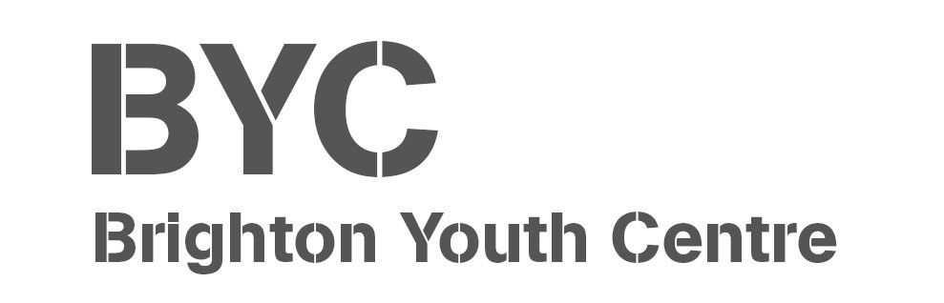

Booking Enquiry Form

CONTACT DETAILS
Contact Name: ______________________________________________________________
Organisation Name: __________________________________________________________
Contact Address: _____________________________________________________________
Contact Telephone Number: ___________________________________________________

HIRE DETAILS
Room/space required: ________________________________________________________
Start Date of Hire: ____________________________________________________________
End Date of Hire: _____________________________________________________________
Start Time: __________________________________________________________________
End Time: __________________________________________________________________
Frequency: _________________________________________________________________
Number of people expected to attend: ___________________________________________
Will you require any equipment to be provided by BYC during your booking? (Chairs, Tables, TVs, Projectors etc.)
___________________________________________________________________________
___________________________________________________________________________

ADDITIONAL HIRE DETAILS (If you require more additional rooms than you are able to enter on this form, please speak to BYC Admin Staff)
Room Required: ______________________________________________________________
Start Date of Hire: ____________________________________________________________
End Date of Hire: _____________________________________________________________
Start Time: __________________________________________________________________
End Time: ___________________________________________________________________
Purpose of Hire: ______________________________________________________________
Number of people expected to attend: ___________________________________________

DISCOUNT APPLICATION
Would you like to apply for discounted room rates?
(Discounted room rate application forms can be provided by Brighton Youth Centre Staff, once submitted this will allow us to assess whether we are able to offer your group a discount, approval of discounts and discount rates are decided on a case-by-case basis and may vary from group to group)
Y / N
____________________________________________________________________
BYC PARTNERSHIP
Would your group be interested in a partnership with Brighton Youth Centre?
(Partnership forms will be provided by Brighton Youth Centre, Partnerships vary from group to group and can encompass specific agreements made between yourselves and Brighton Youth Centre that are not restricted to discounted rates, special considerations for your group may include things such as integrated work and joint programming, additional staffing and staff training provided by BYC, assistance with obtaining DBS checks, and further financial assistance in various forms such as fundraising, exchange of services for room hire, advertising through our social media platforms etc.)
Y / N

DATA PROTECTION
The information you have provided will be processed in accordance with the Data Protection Act 2018. It will only be used to process your application and will not be passed to any other organisation or 3rd party. It will be kept seven years for administrative and audit purposes.

By signing below, you agree with the terms and conditions listed above, and that any breach of these conditions may result in termination of your booking or incur additional charges where appropriate.

Name: __________________________________________________________________________
Organisation:_____________________________________________________________________
Date: ________________

